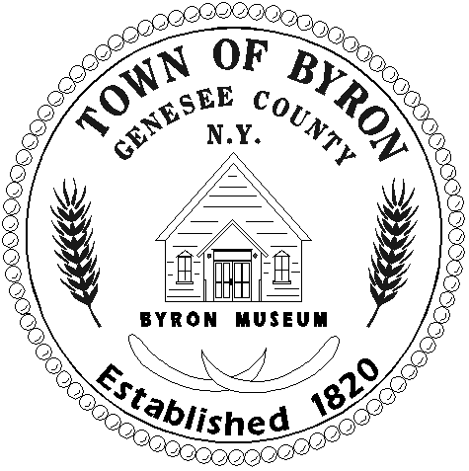

TOWN OF BYRON

7028 Route 237, P.O. Box 9, Byron, New York 14422
Phone: (585) 548-7123 Fax: (585) 548-2812
www.byronny.com

APPLICATION FOR PUBLIC ACCESS TO RECORDS

Date: __________________

To: Debra Buck-Leaton, Records Access Officer
I wish to inspect the following record(s): (Identify records you are interest in as clearly as possible.)

______________________________________________________________________________

______________________________________________________________________________

______________________________________________________________________________

You may inspect documents first and then ask for copies of the ones you actually want.
Number of copies requested: ($.25 per copy) _____

Signature: _______________________________________________________________

Printed Name: _______________________________________________________________

Address: _______________________________________________________________

City/State/Zip: _______________________________________________________________

Daytime Phone: _______________________________________________________________

******************************************************************************

FOR AGENCY USE ONLY

APPROVED
Date ______________ Time ___________________

Photocopies: Number ___________ Charge ___________

DENIED (for the reason(s) checked below)
_____ Exempted by statute other than Freedom of Information
_____ Unwarranted invasion of personal privacy
_____ Would impair contract awards or collective bargaining agreements
_____ Trade secret; confidential commercial information
_____ Law enforcement records
_____ Would endanger the life or safety of any person
_____ Interagency or intra-agency materials
_____ Record is not maintained by this agency
_____ Record of which this agency is legal custodian cannot be found
_____ Other (specify) ______________________________________________________

Any person denied access to records may appeal the denial within 30 days of the denial. Such appeals should be addressed to the Supervisor of the Town of Byron, 7028 Rte. 237, Byron, NY 14422.

